Name: _____________________________Date:_____________________Pd:____
Directions: Read the material provided and answer the questions below.
The Newburgh Conspiracy
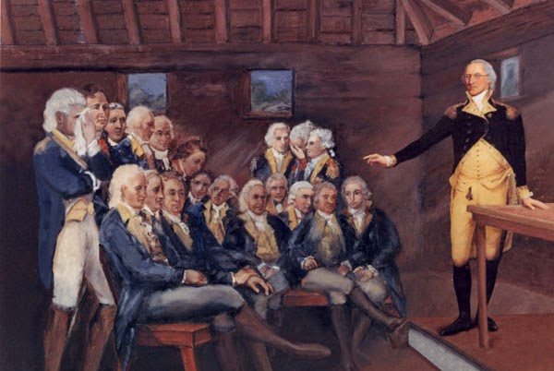
On March 15, 1783, military officers in the Continental Army held a meeting at the American encampment in Newburgh, New York, to decide what to do about growing anger within the army towards the Continental Congress. Originally, Gen. George Washington was not scheduled to attend this meeting. However, as the meeting was about to begin, Washington suddenly appeared in the doorway, and immediately altered the course of events as the Revolutionary War came to an end.
Tension had been growing for years between officers in the Continental Army and the Continental Congress over proper payment for service in the army. The army was much different back then than it is today. Many officers gained their commissions through their own social standings and wealth. Others were nominated by powerful citizens. Nonetheless, a good portion of the officers in the Continental Army were losing money by being away from their farms or businesses while the war waged on. Often, officers used their own money to cloth, feed and arm their soldiers. To counter this, they wrote to Congress that they should be compensated. Congress was being asked to make good on their promises and repay the officers what they felt they were owed for their service to the American Cause.
For their part, the Continental Congress could do very little but make promises to pay the army. Before the Constitution established how the federal and state governments operated, the Articles of Confederation dictated how the new American government worked. Under the Articles, Congress could not tax citizens. It could not raise revenue directly. It had to ask permission from local state governments to tax their citizens and send the money to Congress. This meant that Congress could only hope that people sent money. As confidence plummeted, inflation rapidly drove the price of American notes upward to the point where they were practically worthless. The phrase “not worth a Continental” held a double meaning for those who did not trust the Continental Congress at its word.
By 1782, as the war was coming to an end, many officers within the Continental Army were growing fearful that they would not be paid for their service. Congress insisted that they could pay them for months, not years, of their service. These portions were much smaller than the sums owed. Soon, plans were being drawn up by a select few within the army to threaten Congress. The idea was to tell Congress that unless the demands of the officers were paid, the Continental Army would refuse to disband after the war ended, and threaten to claim power over Congress. This jeopardized the idea of an elected civilian government holding control over the army.
The idea of a standing army was much different in 1783 than it is today. We currently have an army that permanently exists for reasons of safety. In the 18th Century, the idea of an army existing when there was no war frightened people. The threat to stay armed after the war and potentially march on Congress would likely have disastrous consequences for what the American Revolution stood for.
Gen. George Washington knew all too well the frustration with the Continental Congress. He had been dueling with them through letters over how little they did to ease the sufferings of the army since the beginning of the war. Washington sympathized with his officers. However, that doesn’t mean he liked the idea of the army threatening Congress. When word got out in the encampment at Newburgh that the army was planning a coup d’état, Washington realized he had to do something.
On the morning of March 15, 1783, the several officers held a meeting to discuss how to proceed with their plan. Just as the meeting was set to begin, Washington, who had said he would not attend, suddenly appeared in the doorway. Gen. Horatio Gates, who was presiding over the meeting, sat down and gave the room to the American commander. Everyone was shocked to see him, but as the room settled, their anger and frustration remained. Washington thanked the men for their service and then proceeded to give a speech on why their service mattered. Washington was not a talented speaker, and his low voice was uncharacteristically shaky. When he finished, the officers in the room had not changed their minds.
Washington then reached into his coat pocket and pulled out a second speech. As he began reading, he struggled and his hands were visibly shaking. Wiping away tears from his eyes, Washington stopped reading, and pulled out his spectacles. No one had ever seen him with glasses before. It was then that Washington said, “You will have to forgive me; not only have I gone gray, but I have also gone blind in the service to my country.” Washington then proceeded to read how he had been with these men from day one, and had suffered as much, if not more, than any of them. As he finished, the mood in the room had changed. Grown men were now weeping. After Washington left the room, the officers immediately wrote a petition to Congress pledging that they would remain committed to taking orders from the civilian government, and that they would be open to receiving payment when Congress could provide it.
No one knows for sure what would have happened had Washington’s speech failed, and the officers went through with their plan. What we do know is Washington came through once again when it mattered most. Nine months later, on December 23, 1783, George Washington resigned as commander-in-chief of the Continental Army. When he heard, King George III reportedly said, “If true, Washington is the greatest man in the world.” Whether that is true or not, it is clear that Washington’s presence and his delivery at Newburgh put down a conspiracy to destroy the fragile power of civilian government and jeopardize the principles of the American Revolution.
Questions:
1. Ultimately, what did Washington’s second speech convince the military officers in the Continental Army to do?
_______________________________________________________________________________________________________________________________________________________________________________________________________________________________________________________________
2. Why do you believe the Newburgh Conspiracy could have been disastrous for the United States if it had worked?
______________________________________________________________________________________________________________________________________________________________________________________________________
3. Why did Congress not have the authority to raise money to pay the army?
____________________________________________________________________________________________________________________________________
4. What about a standing army was threatening in the 18th Century?
____________________________________________________________________________________________________________________________________
5. When Washington gave his second speech, he used his reading glasses to great effect. Some historians have speculated that Washington might have been purposely acting to sway the emotions of the officers in the room. If true, does it matter that Washington might have been acting and had not spoken with genuine emotion? Why or why not?
________________________________________________________________________________________________________________________________________________________________________________________________________________________________________________________________________________________________________________________________________________________________________________________________________________________________________________________________________________________________________________________________________________
6. The use of imagery can become a powerful tool of influencing how we view and judge situations. (Remember Paul Revere’s broadside of the Boston Massacre) Take for example the picture located on Page 1 here. Consider where the participants are standing and what they are doing. What does this picture say to you?
__________________________________________________________________________________________________________________________________________________________________________________________________________________________________________________________________________________________________________________________________________
7. From what we’ve discussed and learned, what principles of the American Revolution could have been jeopardized had the Newburgh Conspiracy been successful?
__________________________________________________________________________________________________________________________________________________________________________________________________________________________________________________________________________________________________________________________________________

An officer of a country's armed services whose rank is a lieutenant or above.
Unlike today where a typical military enlistment is three years, during the Revolutionary War, enlistments varied from three months, six months, a year or longer.
A commission is an instruction, command, or duty given to a person or group of people by the government.
The Articles of Confederation were adopted in 1781 and served as the official form of government for the United States until being replaced by the Constitution in 1788.
A general increase in prices and fall in the purchasing value of money.
A note is legal paper tender. We commonly call notes bills, as in dollar bill.
Congress offered to pay for six months, far less than many officers had requested.
Considered unnecessary and a threat, standing armies were precisely what Boston colonists had protested against in the 1760s and 1770s when British soldiers were stationed throughout the city.
A coup d’état is an unauthorized and illegal overthrow of political or military power.
March 15th is called the Ides of March; it is the day where in 44BC; Roman Senators betrayed and murdered Roman general Julius Caesar.

